Steering Committee

Rob Krain, Chair
Black Swamp Conservancy

Pat Deering
Licking SWCD

Jonathan Ferbrache
Farfield SWCD

Rob Galloway
Gates Mills
Land Conservancy

Steve Goodwin
Appalachia Ohio Alliance

Ross LeBold
The Nature Conservancy

Krista Magaw
Tecumseh Land Trust

Joy Mulinex
Western Reserve
Land Conservancy

Eric Oberg
Rails-to-Trails Conservancy

Dave Vasarhelyi
Trust for Public Land

Carolyn Waldron
Land Trust Alliance

Andy Dickerson
Cardinal Land Conservancy

October 3rd, 2017

Dear Friend of Ohio Land Trusts,

I write to invite you to join or renew your Membership for the Coalition of Ohio Land Trusts (COLT) for the 2017/2018 year.

COLT was organized in 2004 to help serve the state’s land trusts by providing a centralized source of information, a shared network of resources and experts, and statewide meetings for professional development, education, and training.

COLT is managed and led by a volunteer Steering Committee, who are uncompensated financially and give of their time to help address and advance the needs of Ohio land trusts. The Steering Committee meets monthly, keeps abreast of issues and developments affecting Ohio’s conservation community, and advocates for conservation interests.

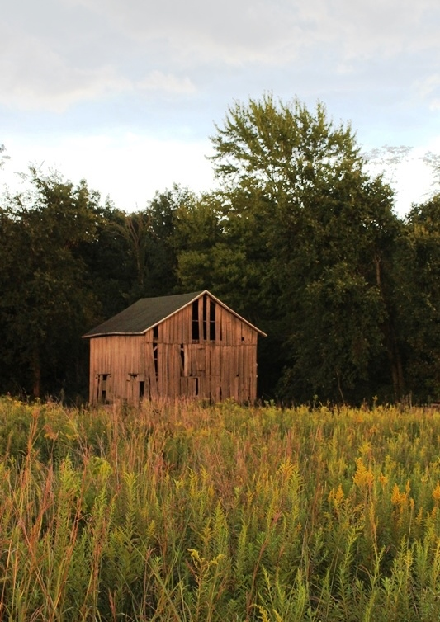
2016-2017 Accomplishments

Last November, COLT sponsored its annual statewide meeting. More than 70 land trust board members, staff, and volunteers attended to learn the latest about In-Lieu Fee Mitigation, the Clean Ohio Green Space Program, Land Trust Standards and Practices, and the Ohio Pollinator Initiative.

Our support of land trust training and development was furthered by COLT’s co-sponsorship of the Land Trust Alliance’s Ohio Circuit Rider Program. This program is working to train four Ohio land trusts (selected by the Alliance) on land trust Standards and Practices and to help prepare them for the accreditation process.
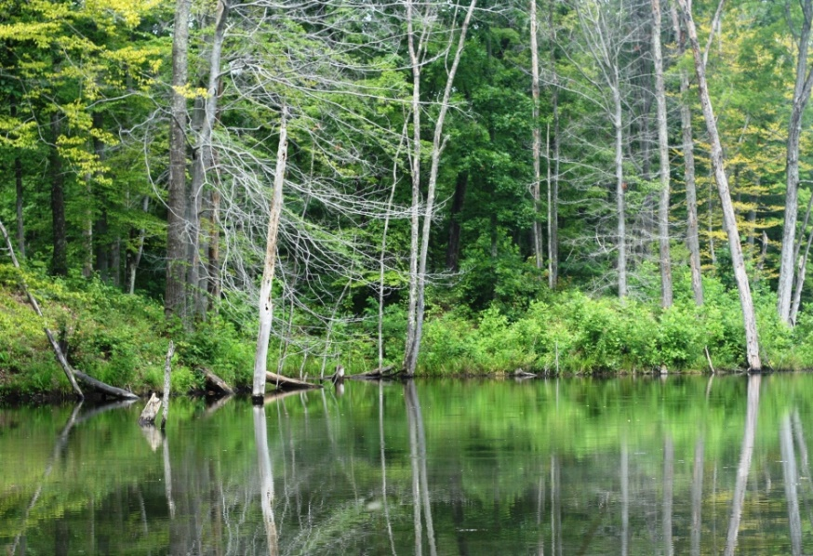
The COLT Steering Committee has also been working on creating a whitepaper document advocating legislative and administrative priorities for the upcoming election cycle. A draft version of this document will be available for review and comment at the fall conference.

Finally, COLT responded to two major issues facing Ohio’s conservation community this year, both of which will be explained in more detail at our upcoming fall conference.

We became aware that Ohio Department of Agriculture’s template deed of easement conflicted with treasury regulations and a recent case law concerning the deductability of bargain sale conservation easement transactions. This issue had far-ranging implications, as more than 20 entities across the state participate in the program. COLT informed the Department of the issue with its language and conferred with national experts in drafting alternative language that both fit the program structure and complied with treasury regulations. In August, the Department modified its easement template for landowners seeking a tax deduction from their easement transaction.

In April of this year, the Butler County common pleas court ruled that restrictions on subdivision contained in a conservation easement are “invalid and unenforceable”. This ruling has the potential to set precedent affecting not only all conservation easements in Ohio, but also nationally. COLT worked in partnership with the Land Trust Alliance and American Farmland Trust to draft and submit a joint Amicus Curiae Brief to the court arguing against the ruling. We continue to monitor this case and stand ready to help defend against this short-sighted ruling if further action is needed.

2017-2018

Land Trusts continue to encounter new and frustrating challenges with many of the land conservation and water quality protection programs we utilize. COLT is in active discussions with these agencies and other key players to address challenges, simplify processes, and advance conservation in Ohio.

We also continue working with legislators and agency representatives to promote property tax reductions on permanently preserved natural habitats that don’t currently qualify for CAUV reductions. We believe this would encourage more private landowners to pursue conservation easement transactions.

Please consider renewing your membership or joining as a new member today!

Memberships help support all of these activities, services, and resources. We ask that you renew your membership or become a new member as we kick-off our annual membership campaign for 2017/2018. Membership fees are unchanged from last year. Your membership helps underwrite the costs of our annual meeting, website subscription/maintenance fees, mailings, and misc. costs.

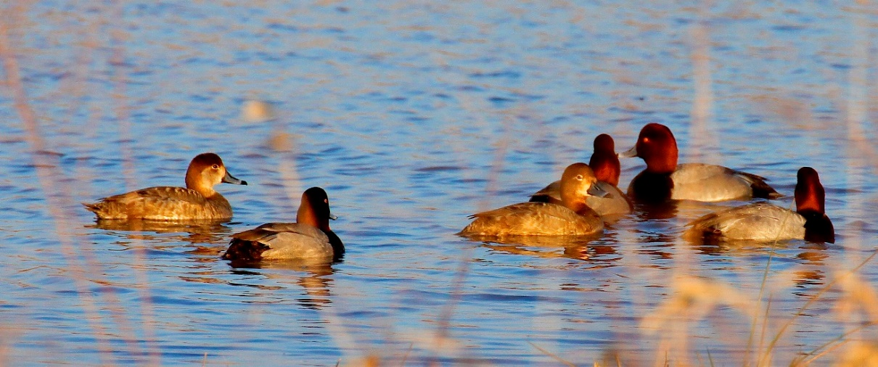

Funds are not used to support or hire administrative staff. Western Reserve Land Conservancy has generously volunteered to continue to provide minimal administrative support and the organizations represented on the COLT Steering Committee will continue to provide in-kind support and staff involvement.

Membership fees are structured at the organizational or individual levels. Members receive advanced information and a reduced registration fee for statewide meetings. Organizations are not limited as to the number of employees or board members registering for our meetings to secure the member registration fee.

All members of the Steering Committee are available to provide additional information or answer questions. Our contact information can be found on the COLT website. Thank you for your support in helping to continue the good work that the Coalition of Ohio Land Trusts is leading in our state!

Sincerely,

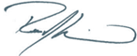

Rob Krain
Chairperson

http://www.ohiolandtrusts.org/, https://www.facebook.com/OhioLandTrusts

